# CITIZEN AI: INTELLIGENT CITIZEN ENGAGEMENT PLATFORM



PROJECT DOCUMENTATION :

PROJECT DONE BY :

FATHIMA HASEENA J

FARITHA NEILOFAR S

FATHIMA RUFIYA M

GAYATHRI M

### **Absatract**

**Citizen AI: Intelligent Citizen Engagement Platform** is an AI-powered system that enables seamless interaction between citizens and government agencies. It combines generative AI, sentiment analysis, and real-time dashboards to provide context-aware responses, capture feedback, and deliver insights that improve public service engagement and decision-making.

# **Introduction**

**Citizen AI** is an intelligent citizen engagement platform intended to bridge communication between citizens and public service/government agencies. It enables citizens to ask questions, provide feedback, and explore civic procedures; and enables officials to monitor sentiment, feedback trends, and improve responsiveness.

By leveraging natural language processing, machine learning, and real-time analytics, CITIZEN AI empowers institutions to understand citizen needs, streamline service delivery, and foster meaningful civic participation. The platform simplifies engagement by providing intuitive interfaces for feedback, inquiries, and support, while offering decision-makers actionable insights to improve policies and services.

With CITIZEN AI, organizations can build trust, strengthen accountability, and create a more inclusive digital public sphere where every voice matters.

### **Features**

1. **Chatbot / Virtual Assistant**
   * AI-driven conversational agents provide instant, 24/7 support.
   * Handles FAQs, service requests, and guided navigation with human-like interactions.
2. **Sentiment Analysis**
   * Automatically detects citizen emotions, concerns, and satisfaction levels in conversations.
   * Helps decision-makers understand public sentiment and adjust communication strategies.
3. **Dashboard / Analytics**
   * Centralized dashboard with real-time insights on citizen engagement.
   * Customizable reports and visualizations for tracking performance, feedback, and trends.
4. **Modular Architecture**
   * Flexible, plug-and-play modules that adapt to different organizational needs.
   * Scalable design allowing easy integration with existing systems and future technologies.
5. **Context Tracking**
   * Maintains conversation history and contextual understanding across interactions.
   * Provides personalized, seamless citizen experiences without repetitive information requests.

|  |  |
| --- | --- |
| **Feature** | **Description** |
| **Chatbot / Virtual Assistant** | Real-time conversational interface for citizen queries regarding public services, documents, procedures. Context aware. |
| **Sentiment Analysis** | Analyze textual feedback / citizen messages to determine sentiment (positive, negative, neutral) and trends. |
| **Dashboard / Analytics** | Visualize citizen feedback over time, sentiment trends, most asked questions, etc. |
| **Modular Architecture** | Backend using Flask; AI integration modular; database layer abstracted to allow SQLite or PostgreSQL. |
| **Context Tracking** | The system tracks conversation flow so that responses reflect prior context in the interaction. |

### **Architecture**

The **CITIZEN AI** platform follows a modular, scalable architecture designed to support intelligent citizen engagement through seamless integration of AI, backend services, and user-facing applications.

### **Backend**

### Flask app written in Python. Acts as web server, handles routing, logic for processing chat messages, feedback, sentiment processing.

* Manages core business logic, API services, and integration with external systems.
* Provides secure routing of citizen queries and requests.
* Ensures scalability and fault tolerance for high-volume interactions.

### 2. **AI Components**

* **IBM Granite LLM**:
  + Powers advanced natural language understanding and generation.
  + Handles dynamic citizen interactions and conversational intelligence.
* **IBM Watson NLP**:
  + Provides text analytics, entity recognition, and sentiment analysis.
  + Supports multilingual citizen engagement with high accuracy.

### 3. **Frontend**

Static HTML/CSS/JS (Bootstrap) pages: chat interface, dashboard, feedback pages.

* Web and mobile interfaces for citizens and administrators.
* Intuitive dashboards for analytics, reporting, and case management.
* Supports omnichannel integration (web, mobile apps, chat, social platforms).

### 4. **Database**

Either SQLite (for small / dev use) or PostgreSQL (for production, scale). Stores user messages, feedback entries, sentiment data, possibly log of interactions.

* Centralized storage for citizen profiles, interactions, and historical data.
* Optimized for structured and unstructured data to support AI-driven insights.
* Implements strong security and compliance controls for data privacy.

### 5. **Deployment**

Docker for containerization; environment variables via .env file.

* Cloud-native, containerized architecture for flexible scaling.
* CI/CD pipeline for seamless updates and feature rollouts.
* High availability through distributed deployment across multiple regions.

### **Setup & Installation (Suggested)**

Here is a suggested flow for installing / running locally:

1. Clone the GitHub repo.
2. Create a Python virtual environment (e.g. python3 -m venv venv).
3. Activate environment, install dependencies via pip install -r requirements.txt.
4. Create a .env file to store configuration:
5. AI service credentials (e.g. IBM Granite API Key, Watson credentials)
6. Database connection string (for SQLite or PostgreSQL)
7. Secrets, other config (port, host)
8. Initialize the database (run migrations or setup script). If using SQLite, may just create file. If PostgreSQL, ensure DB exists.
9. Run the Flask app locally (e.g. flask run or python app.py).
10. Access the UI via browser: chat page, feedback page, dashboard.

For production:

1. Use a more robust server (e.g. Gunicorn or uWSGI) behind a reverse proxy (e.g. Nginx).
2. If using PostgreSQL, ensure connection settings, backups, migrations.
3. Containerization (Docker) for easier deployment.
4. Use HTTPS, environment variables for secrets.

### **APIs / Modules (Hypothetical / To Be Defined)**

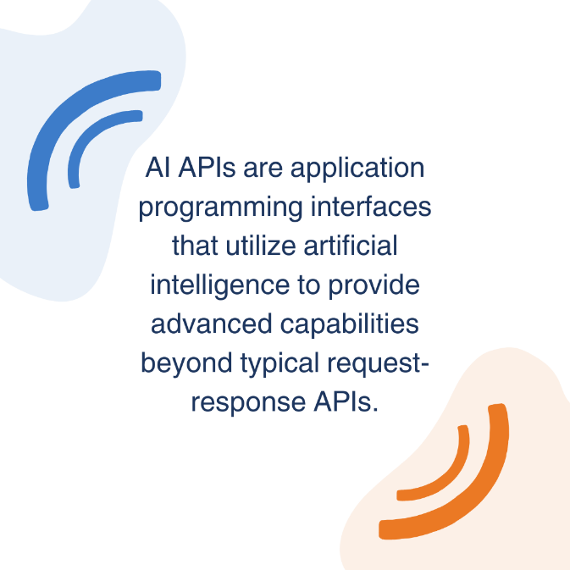

If the system exposes APIs, the endpoints may include:

|  |  |  |  |  |
| --- | --- | --- | --- | --- |
| **Endpoint** | **Method** | **Purpose** | **Input** | **Output** |
| /chat | POST | Send message from citizen to chatbot | JSON with user_id, message, context | JSON with response, possibly updated context |
| /feedback | POST | Submit feedback / rating | JSON with user_id, feedback_text, optional rating | JSON ACK / status |
| /sentiment | GET or POST | Get sentiment analysis of feedback or messages | feedback text(s) | sentiment result + score |
| /dashboard/data | GET | Data for dashboard visualisations | filters (date range, sentiment types) | JSON with counts, trends, etc. |

These should be documented clearly with input validation, error responses, authentication requirements.

### **Data Model**

The **CITIZEN AI** data model organizes and connects the key elements of citizen engagement to ensure smooth interaction, accurate analysis, and actionable insights.

Entities likely needed:

* **User / Citizen** (if login / identity): user id, name, possibly contact, preferences. Represents individuals interacting with the platform, storing identity, login details, and preferences.
* **Conversation / Message**: message text, timestamp, sender (citizen or system), context or conversation id. Captures all exchanges between the citizen and the system (chatbot, virtual assistant, or agent), including timestamps and context.
* **Feedback**: feedback text, timestamp, rating / tags, linked to user or session. Records citizen evaluations of services or interactions, including ratings and comments, to measure satisfaction.
* **Sentiment Record**: for each feedback or message, a sentiment label and score, timestamp. It Stores emotional and sentiment analysis results derived from conversations, helping identify public mood and concerns.
* **Dashboard Metrics**: aggregated counts, trends (may be derived rather than stored). Aggregates data from users, conversations, feedback, and sentiment to generate insights and performance indicators for decision-makers.

Data retention, privacy, anonymization policies are important.

### **Security & Privacy**

**CITIZEN AI** is built with a strong focus on safeguarding citizen data and ensuring compliance with privacy regulations. The platform follows industry best practices to maintain trust, protect sensitive information, and deliver secure digital engagement.

### **1. Data Security**

* End-to-end encryption (in transit and at rest) for all conversations, feedback, and user records.
* Role-based access control (RBAC) to ensure only authorized personnel can access sensitive data.
* Regular security audits, vulnerability assessments, and compliance checks.

### **2. Privacy Protection**

* Adherence to global data protection standards (e.g., GDPR, HIPAA, and local regulatory requirements).
* Data minimization and anonymization to reduce exposure of personally identifiable information (PII).
* Clear consent management, allowing citizens to control how their data is collected and used.

### **3. Identity & Access Management**

* Secure authentication methods (multi-factor authentication, SSO support).
* Session monitoring and automatic logout to prevent unauthorized access.
* Citizen identity protection through tokenized identifiers.

### **4. Monitoring & Compliance**

* Continuous monitoring for suspicious activity or breaches.
* Audit trails and logging of all system interactions for accountability.
* Compliance with government and enterprise security frameworks.

### **5. Trust & Transparency**

* Clear communication on how data is stored, processed, and protected.
* Options for citizens to view, download, or request deletion of their data.
* Commitment to ethical AI practices, ensuring fair, unbiased, and explainable outcomes.

### **Limitations / Known Issues**

While **CITIZEN AI** provides robust features for intelligent citizen engagement, the following limitations are recognized:

* **AI Accuracy** – Responses may vary depending on the complexity of citizen queries; continuous training is required for higher accuracy.
* **Language Coverage** – Although multilingual support is available, performance may be limited for less common languages or dialects.
* **Sentiment Analysis** – Emotional context detection may not always be precise, especially in sarcasm, mixed expressions, or culturally nuanced text.
* **Integration Dependencies** – Smooth operation relies on proper configuration of external systems (databases, APIs, legacy platforms).
* **Scalability Constraints** – High traffic surges may impact response time if infrastructure resources are not scaled appropriately.
* **Feedback Bias** – Collected feedback may not fully represent all citizens, leading to skewed insights.
* **Data Privacy Regulations** – Compliance requirements may vary across regions, requiring ongoing adjustments.

### **Maintenance & Extensions**

The **CITIZEN AI** platform is built to remain reliable, secure, and adaptable over time. To achieve this, the system supports structured **maintenance practices** and flexible **extension capabilities**.

**Maintenance :**

It focuses on keeping the platform stable, secure, and efficient. This includes applying regular updates to AI components, patching security vulnerabilities, monitoring system performance, and ensuring data integrity through backups and cleanup routines. Ongoing maintenance ensures that citizen interactions remain seamless and that the platform stays compliant with evolving regulations and standards.

* **Regular Updates** – AI models, security patches, and system libraries are updated to ensure optimal performance and compliance.
* **Monitoring & Logging** – Continuous monitoring of system health, performance, and citizen interactions with detailed logs for troubleshooting.
* **Data Management** – Routine database backups, archival of old records, and cleanup of redundant data to maintain efficiency.
* **Support & Issue Resolution** – A structured process for bug tracking, incident management, and applying fixes without disrupting service.

**Extensions** :

It allows the platform to grow and adapt to new requirements without disrupting core services. Its modular architecture makes it easy to add new features, integrate with third-party systems, and deploy custom AI models tailored to specific domains such as healthcare, transportation, or public safety. The cloud-native design also supports scalability, enabling the platform to handle increasing citizen engagement needs and expand into new communication channels like voice assistants or IoT devices.

* **Modular Add-Ons** – New features (e.g., additional chatbots, survey modules, or analytics components) can be integrated without impacting core services.
* **Third-Party Integrations** – Easy connection with government systems, CRMs, social media platforms, and external APIs.
* **Custom AI Models** – Domain-specific AI enhancements (e.g., healthcare, transportation, public safety) for tailored citizen engagement.
* **Scalability Options** – Cloud-based architecture allows horizontal and vertical scaling to support growing populations and new use cases.
* **Multi-Channel Expansion** – Future support for voice assistants, IoT devices, and emerging communication channels.

Now , you can see our model is being Dowmnloaded and application is running.

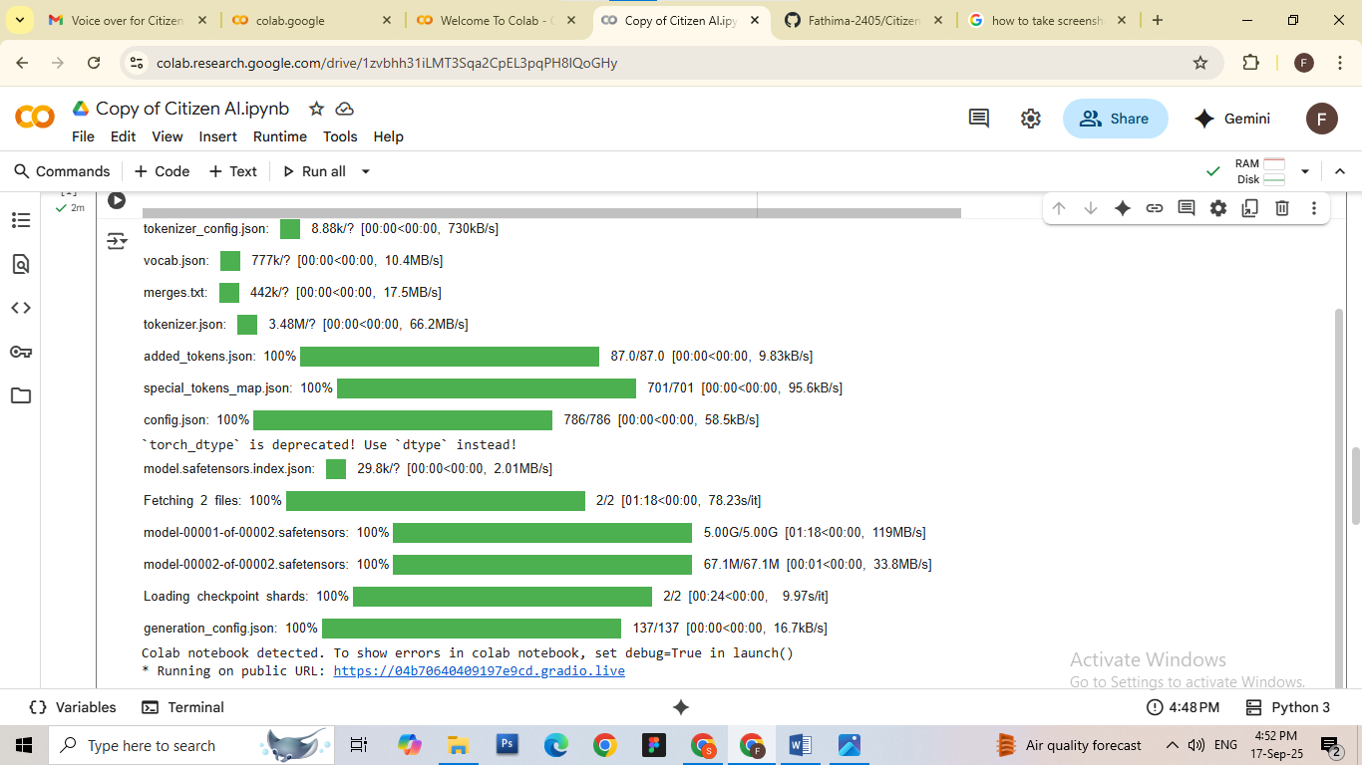

Running on public URL: [https://a9c60b32ea7a486470.gradio.live](https://a9c60b32ea7a486470.gradio.live/)

You can view the Application is running in above link

**Output For City Analysis**

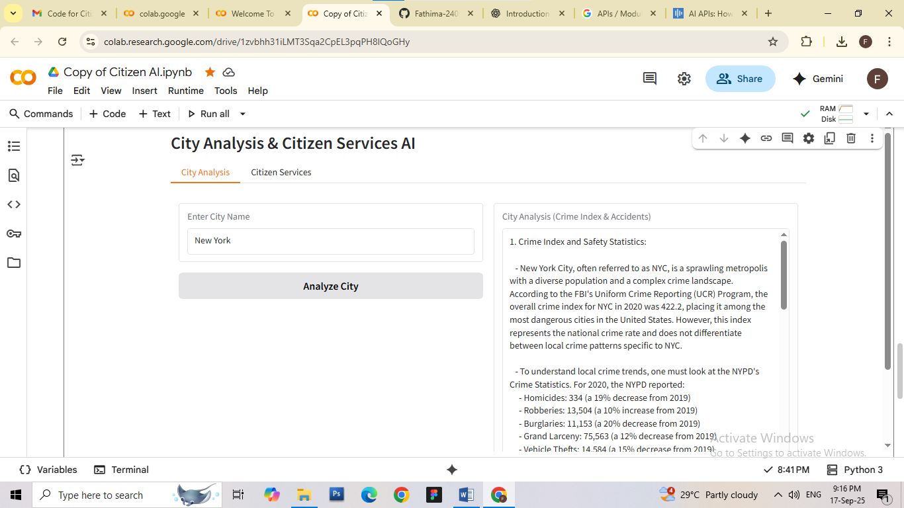

### **Conclusion**

**CITIZEN AI** represents a next-generation approach to digital governance and citizen engagement. By combining AI-powered conversation tools, sentiment analysis, real-time analytics, and a scalable architecture, the platform empowers governments and organizations to deliver transparent, efficient, and citizen-centric services.

Through its focus on **personalized interactions, actionable insights, and trust-building**, CITIZEN AI not only improves service delivery but also strengthens the relationship between institutions and the public. Its modular and extensible design ensures long-term adaptability, enabling continuous improvements as technology and citizen expectations evolve.

In essence, **CITIZEN AI bridges the gap between citizens and institutions**, fostering inclusiveness, accountability, and smarter decision-making for a more connected and empowered society.

**CITIZEN AI** ensures that **every citizen interaction is secure, private, and trustworthy**, enabling governments and organizations to build lasting confidence in digital engagement.

**“CITIZEN AI – Empowering citizens, enabling trust, and shaping the future of engagement.”**